**Pizza Sales SQL Queries**

1. KPI’s

1. Total Revenue:

select sum(total_price)AS Total_Revenue from pizza_sales;

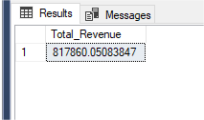

2. Average Order Value:

select sum(total_price)/count(distinct order_id) AS Avg_Order_Value from pizza_sales;

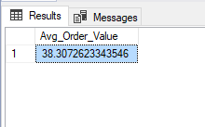

3. Total pizza sold:

select sum(quantity) as Total_pizza_sold from pizza_sales;

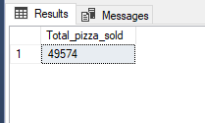

4. Total order:

select count(distinct order_id) as Total_Order from pizza_sales;

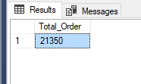

5. Average pizza per order:

select cast(cast(sum(quantity) as decimal(10,2))/

cast(count (distinct order_id)as decimal(10,2)) as decimal(10,2)) as avg_pizza_per_order from pizza_sales;

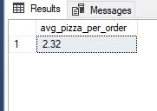

Charts Requirement

1. Daily trend for total orders:

select DATENAME(dw, order_date) as order_day, count(distinct order_id) as Total_order from pizza_sales group by datename(dw, order_date);

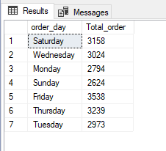

2. Hourly trend for total orders:

select DATENAME(MONTH, order_date) as months_name, count(distinct order_id)

as total_order

from pizza_sales

group by datename(month, order_date)

order by total_order desc;

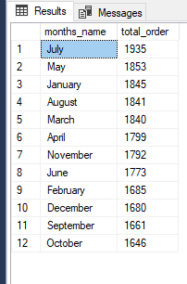

3. Percentage sales by pizza category:

SELECT pizza_category, SUM(total_price) as total_sales,

SUM(total_price) * 100 / (SELECT SUM(total_price) from pizza_sales where month(order_date) = 1) as PCT

FROM pizza_sales

where month(order_date) = 1

GROUP BY pizza_category

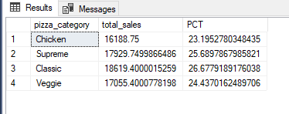

4. Percentage of sales by pizza size:

SELECT pizza_size, cast(SUM(total_price) as decimal(10,2)) as total_sales,

cast(SUM(total_price) * 100 / (SELECT SUM(total_price) from pizza_sales) as decimal(10,2)) as PCT

FROM pizza_sales

Datepart(quarter, order_date) = 1

GROUP BY pizza_size

order by PCT desc

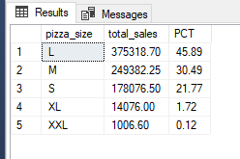

5. total pizza sale by pizza category:

SELECT pizza_category, SUM(quantity) as Total_Quantity_Sold

FROM pizza_sales

WHERE MONTH(order_date) = 2

GROUP BY pizza_category

ORDER BY Total_Quantity_Sold DESC

***Output***

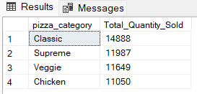

6. Top 5 best sellers by revenue, total quantity and total orders:

SELECT Top 5 pizza_name, SUM(total_price) AS Total_Revenue

FROM pizza_sales

GROUP BY pizza_name

ORDER BY Total_Revenue DESC

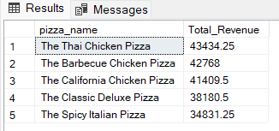

7. Bottom 5 pizza:

SELECT Top 5 pizza_name, SUM(total_price) AS Total_Revenue

FROM pizza_sales

GROUP BY pizza_name

ORDER BY Total_Revenue ASC

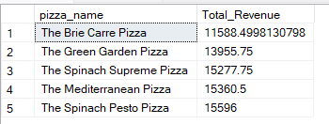

8. Top 5 pizza by quantity:

SELECT Top 5 pizza_name, SUM(quantity) AS Total_Pizza_Sold

FROM pizza_sales

GROUP BY pizza_name

ORDER BY Total_Pizza_Sold DESC

***Output***

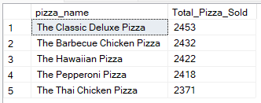

**9. Bottom 5 Pizzas by Quantity**

SELECT TOP 5 pizza_name, SUM(quantity) AS Total_Pizza_Sold

FROM pizza_sales

GROUP BY pizza_name

ORDER BY Total_Pizza_Sold ASC

***Output***

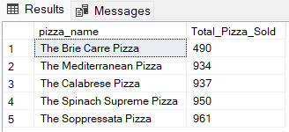

10. **Top 5 Pizzas by Total Orders**

SELECT Top 5 pizza_name, COUNT(DISTINCT order_id) AS Total_Orders

FROM pizza_sales

GROUP BY pizza_name

ORDER BY Total_Orders DESC

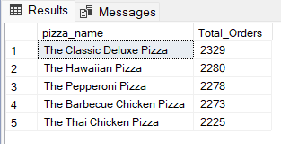

**11. Bottom 5 Pizzas by Total Orders**

SELECT Top 5 pizza_name, COUNT(DISTINCT order_id) AS Total_Orders

FROM pizza_sales

GROUP BY pizza_name

ORDER BY Total_Orders ASC

